Revised: January 2023

PRODUCT LISTING INFORMATION
How to apply for listing with Manitoba Liquor & Lotteries

Table of Contents

Product Listing Process (for wine, spirits, refreshment beverages and MBLL distributed beer sold in Liquor Marts) 2
STEP ONE – Review Call for Listing Schedule 2
STEP TWO – Review Call for Listing Notices 2
STEP THREE – Complete Application Package 3
STEP FOUR – Category Manager Pre-Selection Review 6
STEP FIVE – Notice of Successful Listing 6
Innovative Products Program Application 7
Assortment Enhancement Program 7
Product Listing Process (for privately distributed beer and refreshment beverages) 8
Liquor Mart Pick List (for privately distributed beer sold in Liquor Marts) 9
Becoming a registered agent in Manitoba 10
Image Requirements 11

Product Listing Process (for wine, spirits, refreshment beverages and MBLL distributed beer sold in Liquor Marts)

STEP ONE – Review Call for Listing Schedule

Review the Call for Listing Schedule on the MBLL Partners website:

www.mbllpartners.ca/liquor-agents-suppliers

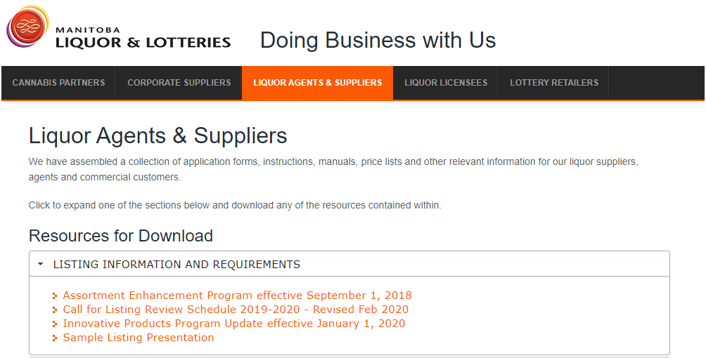

Make note of the timing of the calls and be prepared to apply.

STEP TWO – Review Call for Listing Notices

Following the Call for Listing Schedule, Category Management will post Call for Listing Notices.

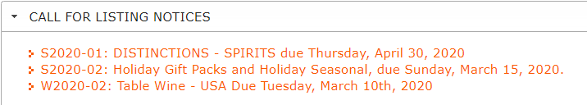

Each Call for Listing Notice will detail application criteria including specific varietals or segments, price points, application limits, closing dates and other important details. Be sure to read each notice carefully.

If you have a product that doesn’t fit the criteria of the Call for Listing Notices, you may apply under the Innovative Products Program at any time. See page 7 for more information.

STEP THREE – Complete Application Package

To be considered for all calls, the following must be included in your application package. Application packages missing any of these components will be considered incomplete and will not be reviewed.

- Product Listing Application Form
- Product Presentation
- High Resolution Image
- Back/Side Label Image
- Supplier Information Form
- Letter of Representation/Authorization
- Declaration of Origin (if applicable)
- Annual Declaration of Production (if applicable)
- Social Responsibility Product Listing Guidelines Reviewed

Details of each component are outlined below. Submit your application packages to CategoryManagement@mbll.ca by the deadline indicated on the Call for Listing Notice.

- Product Listing Application Form

There are three different application forms, specific to the product type:
- MBLL Distributed Beer Application Form
- Wine & Spirits Application Form
- MBLL Distributed Refreshment Beverage Application Form¹

Be sure to apply using the correct form. Most up-to-date forms are found here:

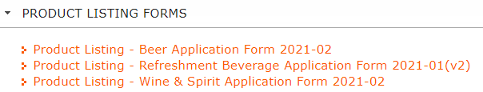

- Product Presentation

All applications must be accompanied by a product presentation. Blank templates for this presentation can be found here:
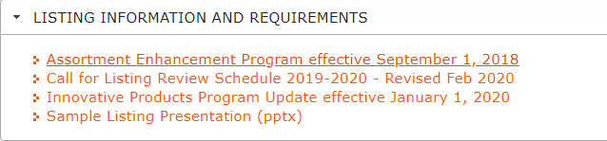

Include product information, market insights, brand performance, marketing support, accolades, etc. This is your opportunity to create a compelling reason why Manitoba consumers will want your product.

- High Resolution Image

A high-resolution image is required for each application. Final images are required (not renderings), as these images are used for our website.

An image of the back label is also required, although this does not require to be high resolution.
More information regarding acceptable image files can be found on page 11.

- Back/Side Label Image

Samples are no longer required, but an image of the back and/or side label is for Category Management to review the label information. Proofs are acceptable, provided that the information on the label matches the product MBLL will be ordering.

- Supplier Information Form

The Supplier Information Form is required for each application. This form outlines payment and shipping information.

Blank forms are found here:

- Letter of Representation/Authorization

A letter of representation/authorization is required if there is not already one on file.

The letter of representation will indicate that a producer or supplier has appointed a specific agency to represent them in Manitoba.

The letter of authorization will indicate that a producer or supplier authorizes MBLL to pay an agency. The letter must clearly include this intention.

There is no template for these letters, but all letters must be on the official letterhead of the producer or supplier, be dated and signed.

For information on how to become a registered agent in Manitoba, please refer to page 10 of this document.

- Declaration of Origin

If the product you are applying for originates from a country that has a trade agreement with Canada, a valid Certificate of Origin should be included. The Certificate of Origin will ensure that the correct duty rates are applied, including any preferential rates.
More information about this can be found here:

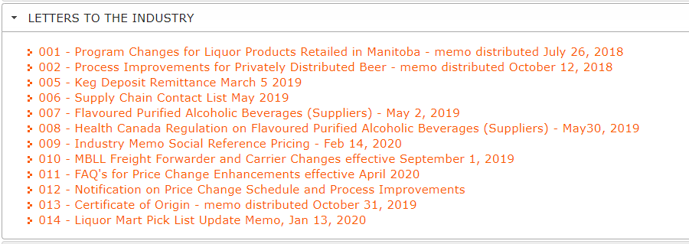

- Annual Declaration of Production

Small producers of beer and spirits may qualify for reduced markups based on their production levels.

If applicable, a completed Annual Declaration of Production form will need to be filled out, accompanied by confirmation from a Certified Independent Auditor of the producer’s volume to qualify for the reduced markups.

More information can be found here:

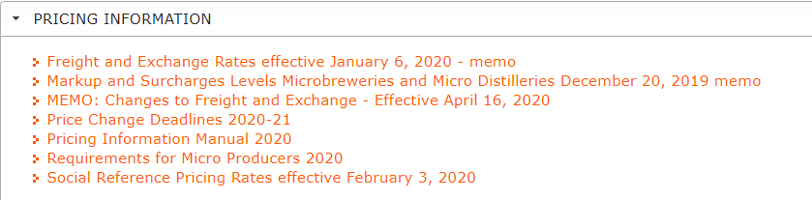

- Review Social Responsibility Product Listing Guidelines

Before submitting your application, please view the new social responsibility product listing guidelines to ensure there will be no issues with your products name, packaging, etc.
Guidelines can be found here:

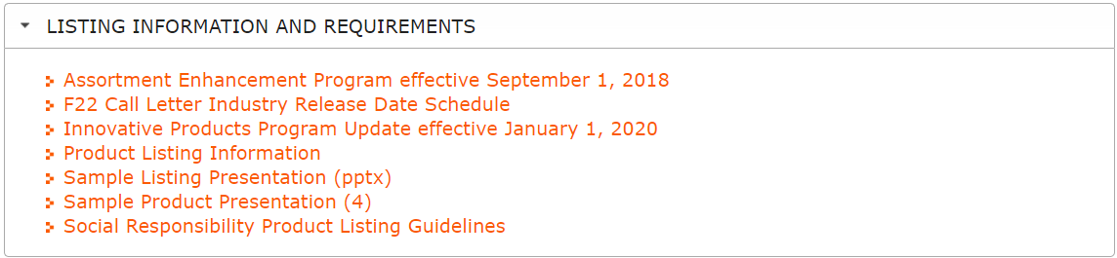

STEP FOUR – Category Manager Pre-Selection Review

After the application deadline has passed, applications will be compiled, and the category manager will conduct a pre-selection review.

Category Manager review takes approximately three weeks.

The following factors are considered during review:
- Alignment to corporate strategy
- Price point, value, trends and market demands
- Marketing support (festivals, social media, TV/radio, billboards, print, etc.)
- Marketing plan (in-store programming – LTOs, AIR MILES, displays, etc.)
- Product appeal
- Brand performance
- Supplier performance
- Market insights

STEP FIVE – Notice of Successful Listing

After the review of the submitted samples, the Category Manager will make a final decision and a Notice of Successful Listing will be emailed to the applicant.

Only successful applicants will be notified.

In the Notice of Successful Listing, the applicant will be notified of the list type assigned to the new item, initial order quantity (if not a regular listed item), and anticipated release for sale date.

Innovative Products Program Application

The Innovative Products Program allows suppliers to enhance the speed to market for new and innovative products while supporting strategic objectives and category development.

Suppliers will be able to submit requests for listings that fall outside the Call for Listing Schedule at any time during the year.

Submissions must be received 10 weeks, plus shipping time prior to the product launch date.
Products must support the four strategic objectives of profitability, customer satisfaction, category growth and innovation.

Products should display one or more the following criteria:
- Reflect trends locally and abroad
- Generate a sense of excitement and consumer appeal
- Demonstrate trending styles through flavour enhancements
- Unique packaging
- Introduce new varietals to the market
- Exhibit leading edge manufacturing methods
- Further enhance the category assortment

Application packages may be submitted to the CategoryManagement@mbll.ca inbox at any time with the subject line “Innovative Products Program”.

Application packages should include all the components outlined under “STEP 3 – Complete Application Package” on page 3.

Assortment Enhancement Program

This program is designed to allow for an open and efficient process to collect and source Distinctions, Allocations, and Bordeaux Futures opportunities.
These products should be presented to the Category Manager via email or in person. The Category Manager will review the information provided and if interested, will pursue the opportunity by requesting an application package. All documentation will be evaluated and a final decision regarding listing and purchase quantity (if applicable), will be determined and communicated to the agent.

Product Listing Process (for privately distributed beer and refreshment beverages)

Applications for beer and refreshment beverages¹ that are warehoused and distributed by an authorized private warehouse may be applied for at any time. Privately distributed beer and refreshment beverages are sold in the private beer vendor channel and can also be restricted to specific licensees.

Liquor Marts only carry privately distributed beer and refreshment beverages that have been approved for the Liquor Mart Pick List. For more information on how to apply for the Liquor Mart Pick List, see page 9.

The Privately Distributed Beer and Refreshment Beverage applications form can be found here:

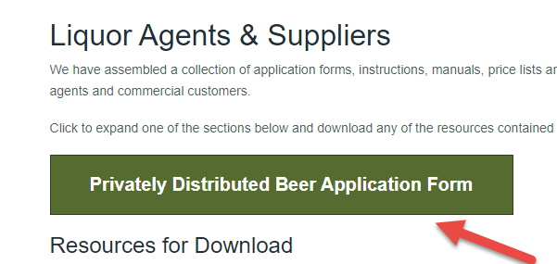

Application packages should include the following components:
- Product Listing Application Form
- Supplier Information Form
- Letter of Representation/Authorization
- Annual Declaration of Production (if applicable)
- Final images of product as well as back label images with content information.

See page 3 for more information on these components.
Suppliers must indicate a product availability date on their application. MBLL requires 5-10 business days to set up and price the product.

Once set up, Product Management Coordination will send the Agent a pricing confirmation e-mail and they will also request a bulletin date for the product in question.

Approvals must be received no later than 11:59 pm the Sunday prior to bulletin date (i.e. if you would like a Tuesday, March 10, 2020 bulletin date, pricing approval & request for that bulletin date must be received by Product Management Coordination no later than 11:59 pm Sunday, March 8, 2020)

On the Monday prior to the bulletin date, an e-mail containing a draft of the bulletin and request for confirmation will be sent from Supplychainadministration@mbll.ca. Approval must be received no later than 11:59 am central time on the Tuesday of bulletin posting.

Items without approval will be removed from the bulletin. If an agent’s items are removed they may request an alternate bulletin date with ProductManagementCoordination@mbll.ca

Liquor Mart Pick List (for privately distributed beer sold in Liquor Marts)

Liquor Marts may only carry privately distributed beer that has been approved for the Liquor Mart Pick List.

Liquor Mart Pick List applications are reviewed in accordance to the Call for Listing Schedule. If there are changes to an existing listing or additions to the Pick List outside of these call periods, the application for the item concerned must be submitted 3 weeks prior to the Friday before the Pick List is bulletined to stores. For example, if you would like an item added or changed on the Pick List on January 31, 2023, you must have the application in by January 6, 2023. *Please note this is just for circumstances that come up outside of our regular calls for listing. This does not mean the Pick List can be applied for at any time.*

To be considered for Pick List approval, applicants must select Yes from the drop-down in this box on the application form:

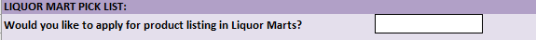

When applying for Pick List approval, your application package should include:

- Product Listing Application Form
- Product Presentation
- High Resolution Image
- Back/side label image
- Supplier Information Form
- Letter of Representation/Authorization
- Declaration of Origin (if applicable)
- Annual Declaration of Production (if applicable)
- Social Responsibility Product Listing Guidelines Reviewed

See page 3 for details on each of the above components.

Application packages may be submitted to: CategoryManagement@mbll.ca

Becoming a registered agent in Manitoba

Although it is not required to have local representation in Manitoba, it is strongly encouraged, as the success of the product relies on help from the agent.

To become a registered agent in Manitoba, you must complete an Agent Information Form and submit it to accounting@mbll.ca

The Agent Information Form can be found on our Partner’s Website here:

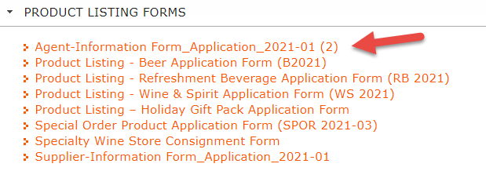

Image Requirements

Images submitted with the application package must follow the following specifications:

- Digital colour image (any format)
  - Bottle/can – 3” wide at 300 dpi
  - Case/package – 5” wide at 300 dpi
  - File share transfers (e.g. We-Transfers) will not be accepted.
- Image must be high-resolution
- Image must show the current label or packaging (current vintage included)
- Image must be transparent or have a white background only
- Image must not have a shadow or reflection
- Image must not depict the product in use (open bottle, poured glass, water droplets, etc.)
- Image must be cropped to size (no white space around the product)

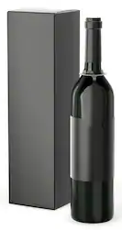
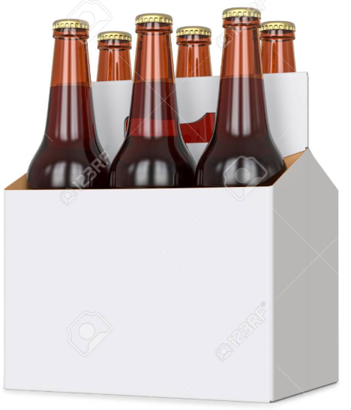
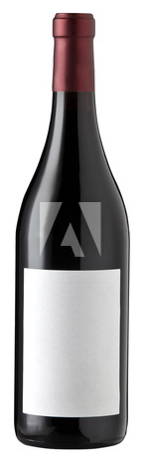
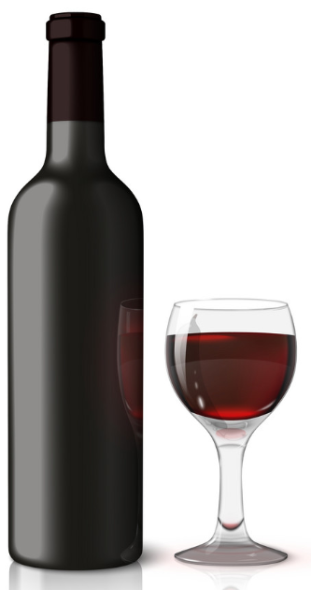
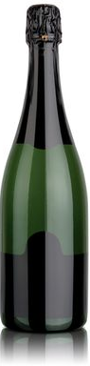
Image has shadow/reflection.
Image shows product in use. (poured glass)
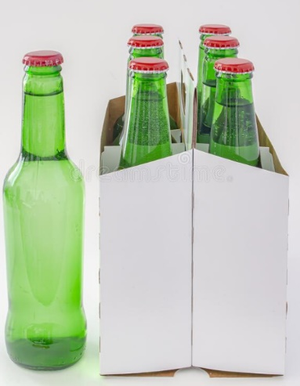
Image must be single bottle or package. Not both.

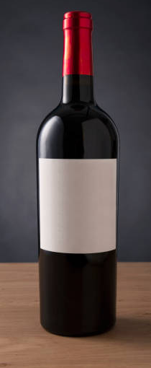
Image does not have a white or transparent background.
Cropped area too large.

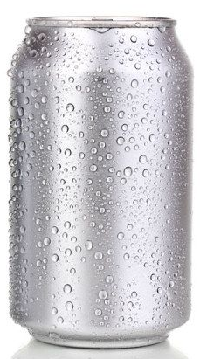
Image shows product in use. (water droplets)

For information on Privately Distributed Beer and Refreshment Beverages, see page 8
Not all suppliers are approved to list privately distributed refreshment beverages at this time.

